







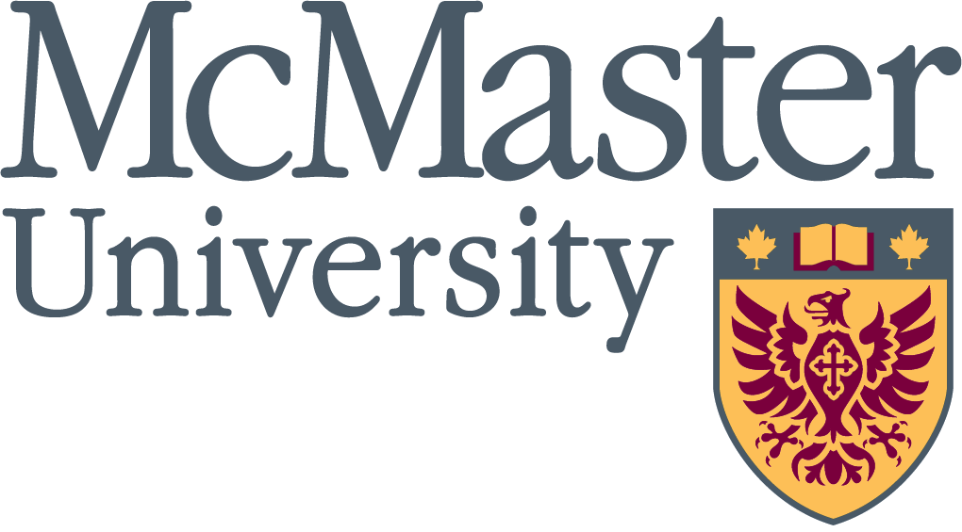

Killam Fellowships Program
CANADIAN STUDENTS | 2026 - 27

Your Study Abroad Experience in the United States
Apply by

December 15,
2025

Contact your Killam adviser

Nancy Solano
Awards Officer
Financial Support, Office of the Registrar
solanon@mcmaster.ca

@FulbrightCanada

AMI BEJKO
KILLAM FELLOW 2025-26


Killam Fellowships Program
The Killam Fellowships Program offers exceptional undergraduate students the opportunity to study in the United States for one semester.
You can participate in one of two ways:
- Direct Exchange: Stay registered at your home university, pay your regular tuition, and study abroad as an exchange student.
- Open Competition: Apply directly to a host university and pay host tuition fees. Existing exchange partnerships between your home university and a non-partner host university fall under this category.
Experience a new culture, expand your academic horizons, and make connections that last a lifetime!







GRANTS
ELIGIBILITY
BENEFITS
APPLY

1 semester

US$6,000

Applications close:
January 31, 2026
11:59 PM
US$750 health insurance allowance
Up to US$800 for in-country travel
Fall Orientation in Ottawa, ON Spring Seminar in Washington, DC
Canadian citizenship
Full-time registered undergraduate student at a Canadian university
Competitive GPA
Acadia University Brock University Carleton University Dalhousie University McGill University McMaster University Memorial University of
Newfoundland
Mount Allison University Queen’s University
Saint Mary’s University
Université de Montréal Université Laval University of Alberta University of Calgary
University of Prince Edward Island University of Toronto
University of Victoria
Western University
York University
PARTNER INSTITUTIONS
AMERICAN
CANADIAN
American University State University of New York Arizona State University College at Plattsburgh
Bridgewater State University University of California at Irvine Clemson University University of Hawaiʻi at Mānoa
Florida Polytechnic University University of Maine
Georgia Institute of Technology University of Texas
at Austin
Ithaca College University of Virginia Miami Dade College University of Washington
Ohio University Wellesley College
Smith College

Killamfellowships.com fulbright.ca
info@fulbright.ca 613-688-5516
@FulbrightCanada

