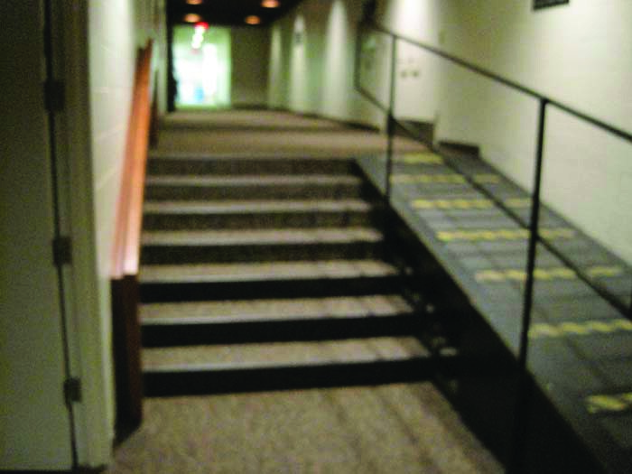 | 1st set of stairs: graduands walk through this hall way to get to the side door of the great hall.
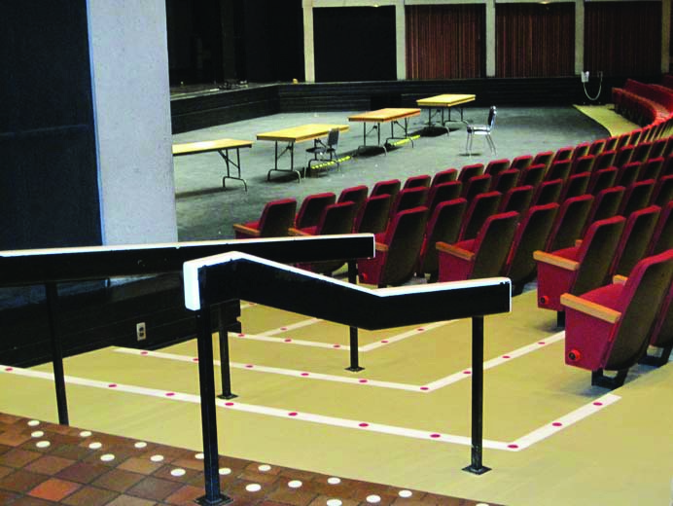 | 2nd set of steps: Once you are in the great hall, you will proceed down this set of steps and turn left (towards stage). Graduand seats are immediately on the right.  There will actually be more graduand/ audience seating where you see those fold-up tables on the black floor.

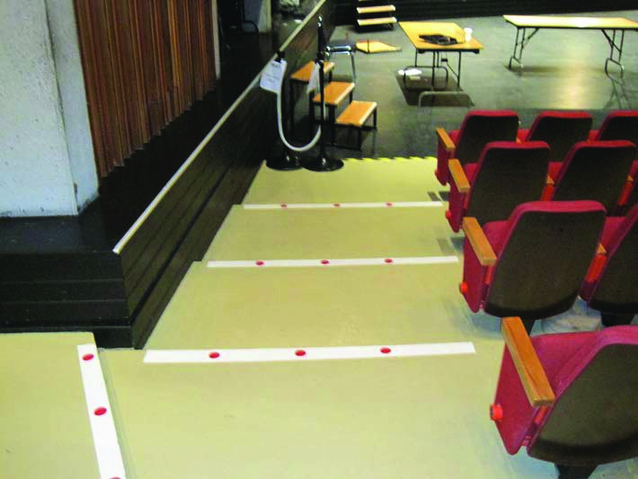 | 2nd set of steps. Another view of the 2nd set of steps, once you turn left. With this part of the steps, there is no railing, but there is a black wall to the left you can hold on to.
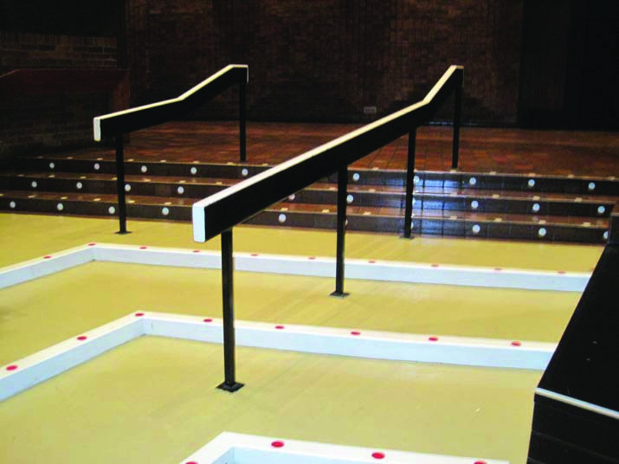 | 2nd set of steps. Another angle of the same set of steps, but looking back at them. The entrance that graduands just walked through is directly ahead and to the right (the black/dark rectangle on the wall).

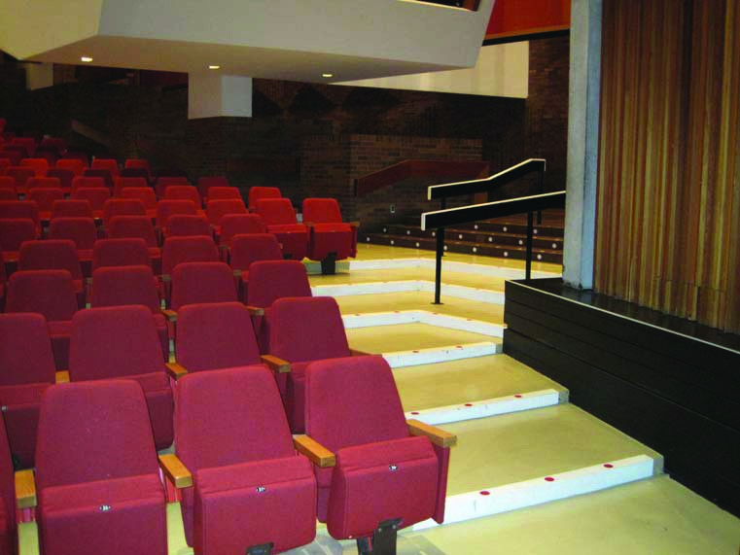 | Same steps as above, but a view of the wall from the stage. Graduands take their seats in these chairs.
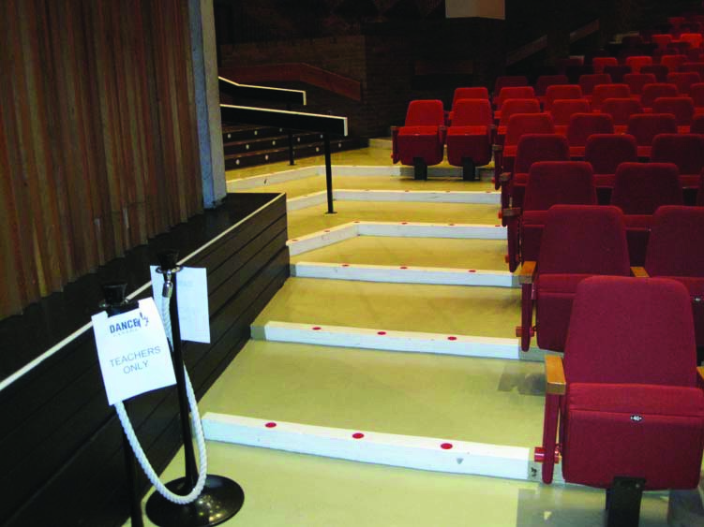 | 3rd set of steps. Once it is time for graduands to make their way to the stage, they will be asked to walk to stage left, and use these stairs. They are on the other side of the great hall, but are similar in design. Graduands will walk up these stairs and turn left.

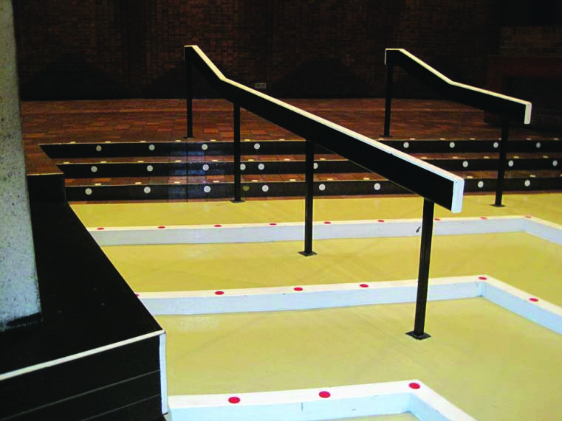 | 3rd set of steps. View of the above steps once you have turned left. Graduands will turn left once again.
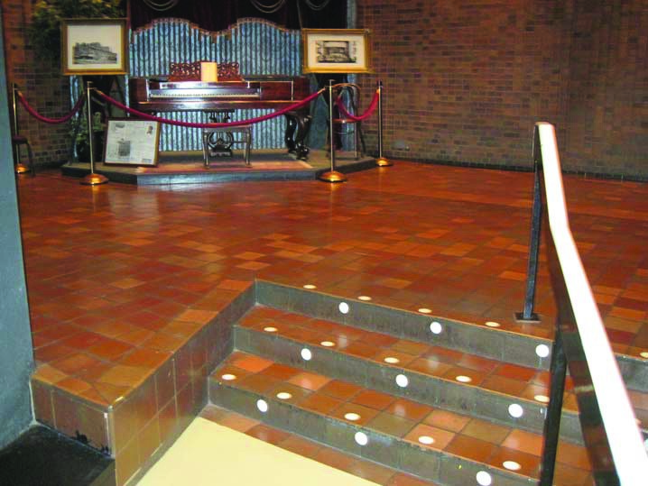 | 4th set of steps. Once you have turned left again.

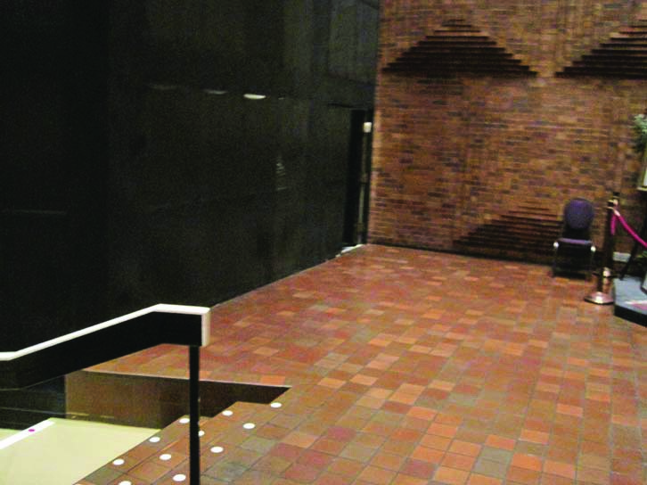 | The entrance to stage is at the very end of this black wall, where it meets the brick wall (note arrow).
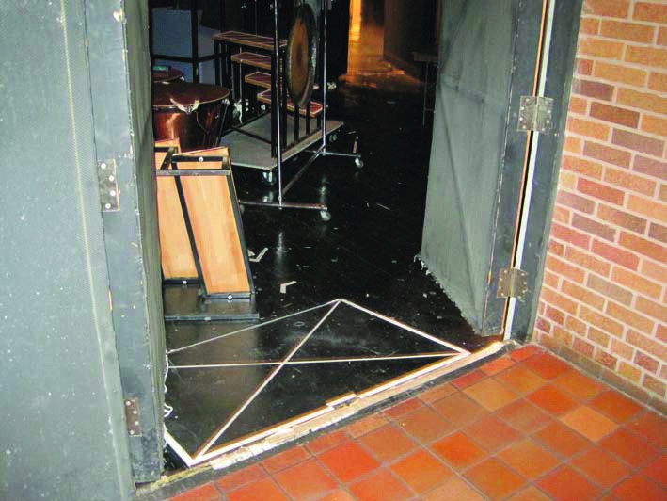 | This is the stage door, and has a small ramp that takes you down about 6” to stage level. All of this equipment will not be in the way for the McMaster ceremonies.
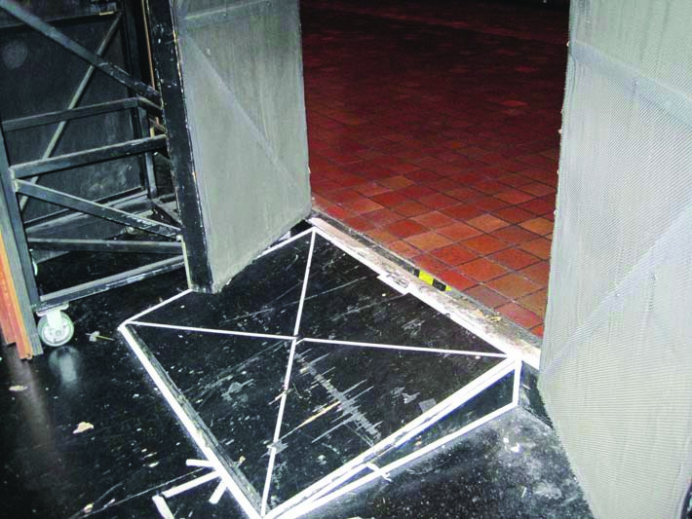 | Another view of the ramp to step down to stage level.  Once graduands go on stage (and kneel to be hooded) they will proceed to the other side of the stage, where there is another ramp like this one to bring up back out to the audience.  Then graduands will take the same steps (as described above) to return to their seats.

